
Register Number

SRM INSTITUTE OF SCIENCE AND TECHNOLOGY
Set - A
SRM Nagar, Kattankulathur – 603203, Chengalpattu District, Tamil Nadu
College of Engineering and Technology
School of Computing
Department of Data Science and Business Systems
Academic Year: 2023-24 (Odd)

Test | : CLA-T2 | Date | : 10-10-2023
Course Code & Title | : 18CSE487T – Data warehousing and Its  Applications | Duration | : 90 Minutes
Year & Sem | : III&IV Year /V& VII Sem | Max Marks | : 50

Course Articulation Matrix:
S.No. | Course Outcome | PO1 | PO2 | PO3 | PO4 | PO5 | PO6 | PO7 | PO8 | PO9 | PO10 | PO11 | PO12 | PO13 | PO14 | PO15
1 | CO1 | 3 | - | - | - | - | - | - | - | - | - | - | - | - | - | -
2 | CO2 | 3 | - | - | - | - | - | - | - | - | - | - | - | - | - | -
3 | CO3 | 3 | - | - | - | - | - | - | - | - | - | - | - | - | - | -
4 | CO4 | 3 | - | - | - | - | - | - | - | - | - | - | - | - | - | -
5 | CO5 | 3 | - | - | 3 | - | - | - | - | - | - | - | - | - | - | -
6 | CO6 | 3 | - | - | - | - | - | - | - | - | - | - | - | - | - | -

Part - A
(5 x 1 = 5 Marks)
Instructions: Answer all
Q. No | Question | Marks | BL | CO | PO | PI Code
1 | The type of relationship in star schema is ……………  a) Many to many  b) one to one  c) one too many  d) many to one | 1 | L1 | 2 | 1 | 1.6.1
2 | The ……………… allows the selection of the relevant information necessary for the data warehouse  a) top-down view  b) data warehouse view  c) data source view  d) business query view | 1 | L2 | 2 | 1 | 1.6.1
3 | Dimensionality refers to ___________  a) Cardinality of key values in a star schema  b) The data that describes the transactions in the fact table  c) The level of detail of data that is held in the fact table  d) The level of detail of data that is held in the dimension table | 1 | L2 | 3 | 1 | 1.6.1
4 | Data cubes can grow to n-number of dimensions, thus becoming _______  a) Hypercubes  b) Star Cubes  c) Dimensional Cubes  d) Solid cubes | 1 | L2 | 3 | 1 | 1.6.1
5 | When we ________ the data, we are aggregating the data to a higher level  a) Slice  b) Roll up  c) Accumulate  d) Drill down | 1 | L1 | 4 | 1 | 1.6.1
Part – B
( 3 x 5 = 15 Marks)
Answer ANY THREE Questions
6 | What is snow flake schema? and explain it with any example | 5 | L2 | 2 | 1 | 1.6.1
7 | Explain rollup and drill down operations | 5 | L1 | 2 | 1 | 1.6.4
8 | What are the OLAP guide lines | 5 | L1 | 3 | 1 | 1.6.4
9 | Write about Critical success factors | 5 | L1 | 4 | 1 | 1.6.1
Part – C
( 3 x 10 = 30 Marks)
Answer ANY THREE Questions
10 | Draw the star schema, snowflake schema and galaxy schema for the college applications. | 10 | L3 | 2 | 1 | 3.2.2
(or)
11 | Explain in detail about operating the data ware house. | 10 | L1 | 4 | 1 | 1.6.4
12 | Explain in detail about two dimensional representation and three dimensional representation of product sales details | 10 | L3 | 3 | 1 | 1.6.4
(or)
13 | Write about MOLAP servers with suitable diagram | 10 | L1 | 2 | 1 | 1.6.4
14 | Explain in detail about backup and recovery strategies of data ware house | 10 | L1 | 3 | 1 | 1.6.1
(or)
15 | Explain in detail about meta data tools. | 10 | L2 | 4 | 1 | 1.6.4

Course Outcome (CO) and Bloom’s level (BL) Coverage in Questions

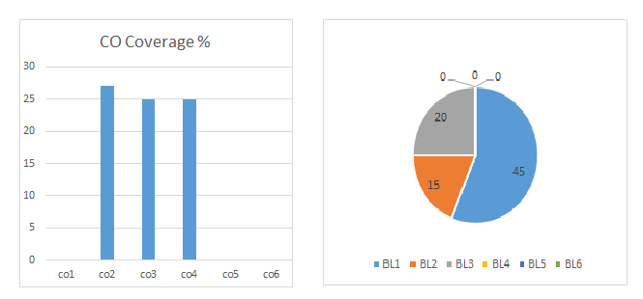

Approved by the Audit Professor/Course Coordinator

